Нестационарные структуры спирального горения на поверхности

АА. Марков1, И.А. Филимонов2,

*1 ФГБУН Институт Проблем Механики им. А.Ю. Ишлинского РАН Россия, Москва, 119526 просп. Вернадского 101б1*

*2 ФГБУН Институт Структурной Макрокинетики и Проблем Материаловедения им. А.Г. Мержанова РАН Россия, Московская область, г. Черноголовка 142432 ул. Академика Осипьяна, д.8*

markov.ipm@yandex.ru, e_filimonov61@inbox.ru

Аннотация

:Рассматривается обобщение теории Новожилова спинового горения, в которой исследовались уравнения баланса тепла и вещества с априори заданным соотношением для орбитальной и поступательной (радиальной) скорости, шага и размера головы спина. Эти данные находились из трансцендентных уравнений для усредненных коэффициентов теплоотвода из головы спина в исходную смесь, в зону продуктов и в центр образца. В представленной работе предлагается двумерная нестационарная модель (2МНМ) поверхностного горения с уравнениями баланса тепла и вещества, и уравнением фильтрации газа на основе закона Дарси. Ключевые слова: умеренные температуры, синтез 

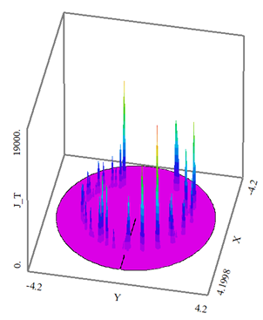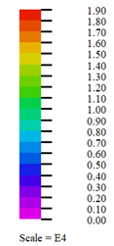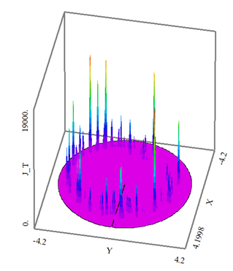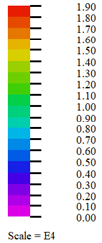

Рис.1 Динамика инициирования режима спинового горения в моменты времени: 0.342(слева) и 0.442 (справа). Иллюстрируется последовательный переход от первой стадии зажигания одноголовым спином (слева) ко второй стадии зажигания, характеризуемой появлением двухголовых и трехголовых спинов, распространяющихся по границе расширяющегося очага материнской волны на периферии реагирующего образца. Существование перехода подтверждается экспериментально [1]

Unsteady patterns of spiral spin combustion on surface

**Andrey A. Markov1 and Igor A. Filimonov2a)**

*11Ishlinskii Institute for Problems in Mechanics, RAS Vernadskii ave101b1,*

*119526, Moscow, Russia*

*2Merzhanov Institute of Structural Macrokinetics and Materials Science(ISMAN) RAS. Academician Osipyan str.8, Chernogolovka Moscow Region 142432 Russia*

[markov.ipm@yandex.ru](mailto:markov.ipm@yandex.ru), e_filimonov61@inbox.ru

**Abstract**

A two-dimensional non-stationary model of surface combustion for gas and solid phases in a porous medium is proposed with equations for the balance of heat and matter in both phases and the gas filtration equation based on Darcy's law. At the initial time, the temperature gradient, gas velocity and reagent concentration are set. On the basis of numerical solution of the governing equations for a given heat exchange with the external environment, the structures of spirally unwinding combustion foci are obtained, which propagate along the boundary of the expanding parent foci. The structures of the thermal field are in the form of intermittent local heated and relatively cold combustion zones, which in some cases have the shape of saw teeth. Such a focal structure of thermal fields is a characteristic of combustion at the diffusion-kinetic limit of propagation of the reaction front. Namely, hot protrusions correspond to local zones of a diffusion-limited reaction, and cold protuberances correspond to local zones of a kinetically-limited reaction. The resulting spiral form of spin combustion has an analogy with the formation of fingers in the modern theory of filtration combustion. Key words: moderate temperatures, synthesis 



**Fig. 1** Propagation of a single-headed vortex in domain: 

Dynamics of spin ignition at the moments: =0.342 (on the left) and =0.442 (on the right). Sequential transition from the ignition first stage initiated by a single-headed spin mode (on the left) to the ignition second stage with double-headed and triple-headed spin modes (on the right) is illustrated. The transition is confirmed experimentally [1]

|  |  |
| --- | --- |
| A time=0.1 | B time=0.14 |

**Fig.2** clockwise movement of a single-headed spin and its azimuth-radial temperature distribution at the moments A and B is presented

|  |  |
| --- | --- |
| C time=0.22 | D time=0.44 |

**Fig.3** counter-clockwise movement of a double-headed spin and its azimuth-radial temperature distributions at the moments C and D is illustrated. One may see transition to a saw-tooth structure of the combustion front moving counterclockwise at the moment D

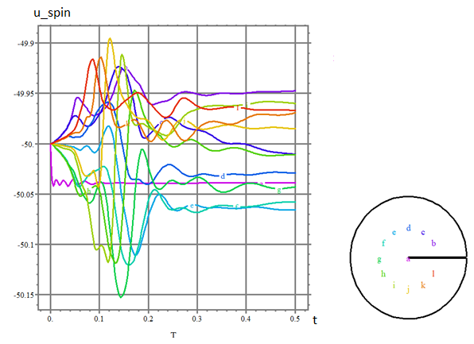

**Fig.4**. Dynamics of the radial component of spin head velocity in a single head spin combustion mode at 0<t<0.5 Dynamics of the radial component of spin head velocity in a single head spin combustion mode at 0<t<0.5 in the sample peripheral points: from a to d

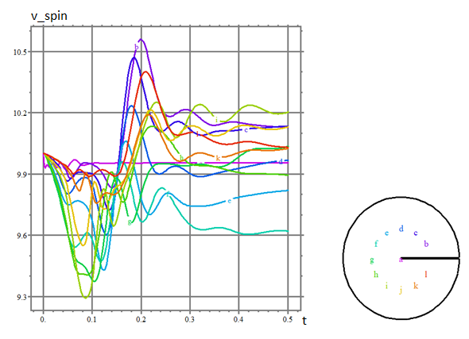

**Fig.5**. combustion mode Dynamics of the orbital component of a spin head velocity both in double-headed and triple-headed modes of spin combustion at 0<t<0.5 in the sample peripheral points: from a to d

Clockwise movement and unwinding of the spiral of the heated combustion zone is presented. Note the formation of a saw-tooth structure of the combustion front, consisting of high-temperature protrusions, which alternate with relatively cold protuberances.

|  |  |
| --- | --- |
|  | 1) spiral initiator; 2) heater wire; 3) layer of Hf powder; 4) tungsten-rhenium VR 5/20 thermocouple; 5)capillary insulator; 6) video camera, 7) mirror  The test samples (Fig. 1) consist of a pipe with an outside diameter D = 3 mm, a wall thickness = 0.75 mm, and a length L = 20-28 mm pressed from hafnium powder (particle size d ~ 10 pm) to a density ρ= (6.2 ± 0.05) 103 kg/m 3. The samples were prepared by axial compression on a 1.5-mm diameter, 45-mm-long alundum capillary. In order to ensure the required durability and a uniform density of the sample along its length, the pressing was done step-by-step in layers of ~3 mm from a paste |

**Fig.6**. Experimental setup from the data [1] on hafnium spin combustion in nitrogen ( Vadchenko, S.G., Filimonov, I.A. 1999).

Dependent on the sample initial surface temperature and the nitrogen pressure in the reaction vessel during the synthesis of hafnium nitride, one-, two- and three-headed spin combustion modes and two layer-by-layer modes (surface and volume) were experimentally observed[1].

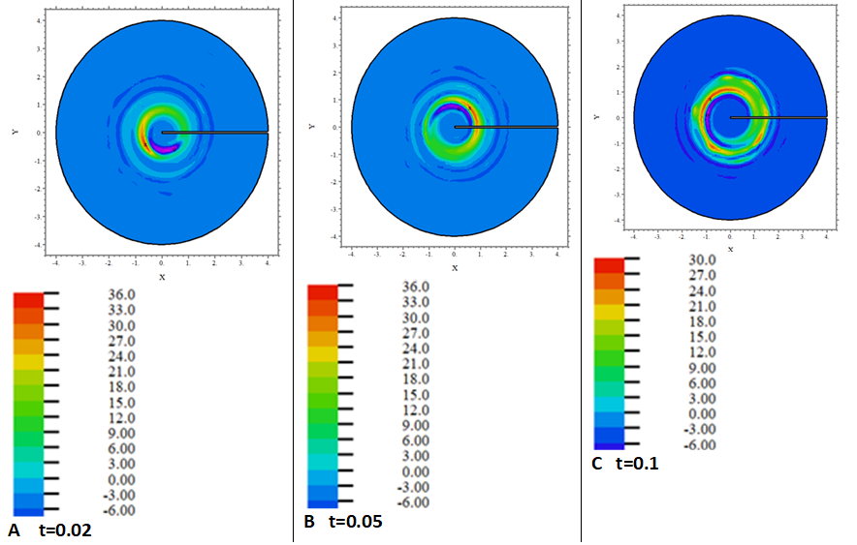**Fig.7**. Appearance of two and three-headed spin combustion modes in azimuth-radial temperature distributions of the reacting sample. Dynamics of spin combustion ignition at the moments: t=0.02, 0.05, 0.1. One may see that a single-headed spin initiated by the non-uniform temperature ignition at t=0.02, 0.05, 0.1 transforms into double-headed and triple-headed spin combustion modes at t=0.2, 0.35 and rotates on the reacting sample periphery. Formation of the double-headed and triple-headed spin combustion modes was confirmed experimentally [1] at the HfN synthesis by spin combustion

**Introduction** Theclassical combustion theory [2-6] considers spin combustion as an unstable mode of the corresponding plane combustion wave or of the combustion wave fronts close to a plane. In the paper presented we consider the synthesis of titanium carbide [7](Le<<1, Ze=6.03 at ), in a spin combustion mode

**Governing Equations**

 , (1)

, (2)

, (3)

, (4)

, (5)

. 6)

System (1-5) is a hydrodynamic generalization of model [8].

**Initial and boundary conditions**

The Initial conditions **(**IC**):**conditions **(**IC**): , ** include conditions for temperature and velocity of the front movement in the head, in the initiation zone (maternal spot) and on the periphery of the vortex. In practice, such conditions can be created by blowing the reacting sample with a gas stream of different intensities [9.10]. Cycling conditions:  are used as boundary conditions (BC). At the external boundary , the conditions of free heat exchange with a given heat exchange coefficient of the order of 1000 are set.

**Previous theory shortcomings**

The main reason for shortcomings is the a priori assumption [11,12] that the surface of combusting sample is consumed by spin and the maternal front with the same rate both in orbital and in longitudinal direction ( the case of a pencil-shaped sample) or in orbital and radial direction (the case of a disk-shaped sample), i.e., the trace from a spin head left after the sample combustion would have to cover its surface with a dense layer, without gaps. Evidently, this is not true in any case [9,10,1]. All the other relations used a priori in [11,12] (relation between spin orbital or radial/longitudinal velocities, between a spin pitch and the preheated layer thickness, and so on.) are, in fact, consequences of the above mentioned only assumption about an uniform entry of the surface of a reacting sample both into the front of the maternal wave and into the head of a spin Thus, the need to revise the existing theory and to change it substantially was evident to us and has been successfully completed now.

**Transient modes of catalytic reactors**

We have to note that there is a strong analogy between spin combustion modes and so called a wrong-way temperature behavior inside catalytic reactors[13,14]. The latter terms are preferred in the American scientific community while the term: spin combustion is more common for the Russian researchers. The reasons of such a difference may be explained by the research directions formed historically in the countries. However, this does not mean that in Russia they did not engage in catalytic reactors at all, and in America they did not study et all spin combustion. Mention of misbehavior of the transient temperatures[13, 14] in catalytic reactors implies that there is a perception of the correct behavior of this temperature presented earlier by the Russian investigators, namely [15]. Despite the difference in terms, We are going to prove that, in fact, spin combustion is very similar to the transient modes and spin combustion is rather very similar to transient modes of catalytic reactors, than is significantly different from them in our opinion. Both spin and the wrong-way temperature behavior are considered as transient states. Spin is a transient between layer-by-layer combustion modes [1] (single-headed or double-headed spins in regions I and II, respectively) and from layer-by-layer combustion to the region of no combustion [1](single-headed spins). Moreover, many features of spin combustion resemble those of the transients in catalysis For example, describing the transient modes of catalytic reactors, the authors [13.14] write that the rapid step increase in the flow rate can generate a transient peak temperature of the solid phase higher than that at the steady state. One may see the same peculiarity in behavior of spin combustion. Let's consider fig.2d in details and see that at the heat removal enhanced up to PeT =10^4 spin combustion may form the saw-tooth structures with the temperature of hot tooth-shaped zones exceeding that of cold tooth-shaped zones and of initial steady states by more than 10 times

**Correct behavior of transient temperatures in catalytic reactors**

Probably, one have to recall the results of [15] in order to better understand all the arguments for and against (if any) combining the wave of transients in catalytic reactors and spin combustion into one group. The general problem of reaction wave propagation on catalytic wires has been quantitatively solved in [15].At the same time, of the travelling waves behavior was investigated numerically and experimentally on the example of the reaction of ammonium oxidation [15]. The calculations [15] are turned out to be in a good agreement with the experiments[15]. At any moment, the transient temperature distributions between the hot zones on the catalyst (A), which are local areas of the diffusion-limited rate of ammonium oxidation and the relatively cold zones (B), which are local areas of the kinetically-limited rate of ammonium oxidation, should be monotonic, smooth and continuously differentiable, smoothly decreasing from A to B. This behavior of the transient temperature was later indirectly attributed to the correct ones [13, 14] and any non-monotonic deviations from this behavior were considered as wrong-way transient temperature behaviors, or, in other words, as a misbehavior of the transient temperature. Explanation [2-6,15] of the correct transient temperature behavior during ammonium oxidation and etc., is based on the fact, that in a gaseous system: and, therefore, the system complete enthalpy, , is a constant as well as a monotonic transient temperature distribution takes place in steady states of the combustion front propagation and there is the linear similarity between the enthalpy (transient temperature) and reagent concentrations,:, i.e.,. Vice versa, at  there is no similarity and the enthalpy (transient temperature) is independent on concentrations. An excess of the enthalpy is formed and leads to formation of a non-monotonicity of the transient temperature and, consequently, to a wrong-way transient temperature behavior [14]

**Effect of reactions on the correct transient temperature behavior**

Unlike platinum (forming a thermally easily disintegrating intermediate PtO2 that does not affect the self-ignition period), palladium wire or tape forms a relatively more stable intermediate product on its surface (PdO) when used as a catalyst for self-ignition of hydrocarbon and hydrocarbon-air mixtures [16]. As a result, thermal and mechanical (diffusion) contact with the catalyst is broken and there is a delay in self-ignition of the gas mixture. It (self-ignition) becomes two-stage [16] and longer in time, with a negative temperature coefficient of the self-ignition period (NTCS). The concept of NTCS, in principle, does not contradict the explanation of a wrong-way transition temperature behavior from the position of excess enthalpy for Lewis numbers of a different magnitude [6], which we have given above, it simply operates in the terms other than enthalpy and similarity of concentrations and temperature fields.

**Incorrect transient temperature behavior in other reaction systems**

Note that abnormal or improper transient temperature behavior is not an exclusive (wrong-way) characteristic of catalytic reactors alone [13,14]. For example, spirally moving hot zones, like a wrong-way transient temperature behavior, are observed with heterogeneous self-ignition of pyrophoric metals and are explained by the authors by the negative temperature coefficient of delay of self-ignition from temperature (NTCS) [16] .NTCS was detected during the study of the ignition of hydrocarbons and hydrocarbon-air mixtures, observed at very low temperatures [16](below 850K), the discussion about the kinetics of their self-ignition under these conditions continues, but one explanation [16] is the formation of nanometric islands of a stable intermediate product on an active catalyst, such as palladium wire etc. Transient temperature in the head of a spin is distributed non-monotonically and exceeds the adiabatic combustion temperature, as well as the product temperature [17], i.e., the conditions of a misbehavior [14] are completely valid for spin combustion too. Transient temperature in the head of a spin is distributed non-monotonically and exceeds the adiabatic combustion temperature, as well as the product temperature [17], i.e., the conditions of a misbehavior [14] are completely valid for spin combustion too . The latter conditions hold also for the scintillation waves accompanying gas-free combustion [18]. Thus, in accordance to literature, a misbehavior of the transient temperature is the common attribute not only for catalytic reactors but for spin combustion also and for the other reaction systems mentioned above. Despite the fact that assumption [11,12] about proportionality between a spin pitch and the maternal preheated layer thickness is not valid in general, some quasistationary results [11,12,19] are in a rather well agreement with the conclusions based on 3D detailed spin modeling [17]. This applies, for example, to radial heat flux from a spin head to the axis of a pencil-shaped reacting sample which is about a constant (within the accuracy of calculations [17]), while vertical heat fluxes from the sample end faces: up, into a cloud of the floating up gas and down, into the supporting substrate are significantly changing.

**Spin and heat flux topology in a spin combustion mode**

In a spin combustion mode [17]. the reacting surface area of a vertical pencil-shaped sample (PSS) doesn't change and thereby provides conservation of the radial flux. Vice versa, the reacting surface area in a disk-shaped horizontally established sample (DSS) during spiral spin combustion of DSS changes drastically as well as the radial heat flux and the flux disregard in[10,11,19] leads to the increased spin velocities (on about 1.5 orders of magnitude) in DSS as has been later revealed by comparison of calculations [19] with experiments [1]. At the same time the vertical heat fluxes: flowing up, into a cloud of floated up heated gas, and down, into a solid substrate with a holder, don't almost change during the spiral spin combustion of a DSS. Double-headed spin was observed both numerically [5,17,20] and experimentally [12], It is well known [21-23], that equations describing a heterogeneous plane combustion wave propagation are equivalent to those of the theory of thermal explosion [1,3,24-30]. The same concerns the spin combustion equations presented. Both spin and heterogeneous plane combustion corresponds to a wrong-way transient temperature behavior [14]. While catalytic reactions on non-pyrophoric metals [31,15] result in the correct transient temperature behavior

**Results and discussion** Some numerical results obtained with the help of model (1-5) suggested are illustrated by figs (1-7). Fig.1 Figure 1 presents the dynamics of a single-headed spin ignition at the successive moments of time: 0.342 (left) and 0.442 (right). As can be seen from Fig. 1, a single-headed spin, initially formed by a temperature-inhomogeneous ignition, eventually transforms into double- and triple-headed complexes of foci moving along the periphery of the reacting sample (double-headed and triple-headed spin combustion modes). Figures 2,3 illustrate the azimuth-radial temperature distributions during a spin combustion ignition. Analysis of these distributions and of their effect on the further course of combustion leads to the conclusion that the assumption of the quasi-stationary theory [11.12] about the negligible effect of radial temperature gradients on the spin propagation (in a disk-shaped sample) is not actually valid. at 0<t<0.5. Figs 4,5 show a dynamics of the radial and orbital components of a spin head velocity both in double-headed and triple-headed modes of a spin combustion rotating on the sample peripheral points: from a to d, at 0<t<0.5. Fig.6 represents the experimental setup which was successfully used for the detection and analysis of data [1] on hafnium spin combustion in nitrogen ( Vadchenko, S.G., Filimonov, I.A. 1999). Fig.7 illustrates azimuth-radial temperature distributions of a spin combustion at the moments: 0.02, 0.05, 0.1 One may see that transition to a saw-tooth structure takes place already at the moment 0.1 of the reaction time.

Thus, the propagation of double-headed and triple headed spin modes rotating clockwise or counterclockwise may be initiated at the first initial stage of the combustion ignition and this possibility is now completely confirmed by experiments [1]. Over time (at the second stage of the ignition and later), in agreement to our calculations the spin modes can turn into a saw -tooth structure (SS) with alternative intermittent local areas of relatively higher and lower temperature (areas of diffusion and kinetically limited reaction). Nevertheless, the appearance of SS has still to be confirmed experimentally According to our opinion, the SS obtained numerically is a two-dimensional analogue of one-dimensional waves of catalytic reactions observed on pyrophoric wires and tapes in the reactive gas stream [16]. and more complex focal nanostructures arise from self-ignition of pyrophoric metals in a gaseous oxidizer [16]. The results obtained now will let us to build a theory of spark plasma sintering technique [32] not existing yet. In our opinion, the mechanism of SS generation is similar analog to that of fingers formation [33] in filtration combustion.

**Gasdynamic comparison of spin combustion with tectonic movements of terrestrial volcanic chains**

There are several facts that probably suggest a possible gas-dynamic similarity of currents arising in spin combustion and currents accompanying the tectonic movements of volcanic chains. Let's consider table No 1 concerning these facts and the gasdynamic criteria built on them:

**Table No1.** **Comparative gasdynamic parameters of flows in spin combustion(on the example of hafnium nitride synthesis [1]) and in tectonic movements of volcanic chains**

|  |  |  |
| --- | --- | --- |
| Process/Parameters | Spin combustion | Сhain of volcanos |
| Life time |  |  |
| Space scale |  |  |
| Relation of scales |  |  |
| Thermal diffusivity |  |  |
| Velocity scale |  |  |
| Reynolds number |  |  |

First, the topology of gasdynamic currents in spin combustion (2- and 3-headed spin modes) bears a resemblance to the climatic vortex pairs of cyclone-anticyclone observed in the Earth's atmosphere**.** Second, according to the table, the scale of speed of a spin head and a hot volcano along the tectonic plate, respectively, is almost the same. However, the Reynolds's number based on volcanic movement data is significantly higher than the same number based on a spin head movement data in the HfN synthesis [1]. Due to the huge difference in the space scales, one may consider gasdynamic flows during spin combustion as rather laminar while the flows accompanying the movement of volcanos are certainly turbulent. Therefore, we can assert with the complete certainty that there is no any similarity between gas dynamics accompanying the movement of volcanoes and gas dynamics in spin combustion and formation of a spin instability does not transform maternal laminar flows into turbulent ones

**Methods** The self-consistent numerical solution of microscopic equations into each cell and macroscopic equations is applied using the splitting technique as described in [23]. The equations are solved numerically using implicit finite difference approximations. Consider a computational cell which volume is V(x, y, z) and the center is located at a node (x, y, z). Let V(x, y, z) n(x, y, z) be the number of particles uniformly distributed inside the cell and b(x, y, z) be the radius of particles. At the first step the heat and mass microscopic transfer coefficients and the values on the particle surface are found by solving the system of Eqs. (3)–(7) in [23]. At the second step the averaged surface mass and thermal fluxes are calculated for macro scale resolution

**Conclusions** The model developed has allowed us to obtain numerically the results consistent with experimental data [9,1 ] Single headed spins are calculated and observed [1] at the quenching limit only. Double headed spin is the most characteristic mode of spin combustion region II both in experiments[1] and in our calculations. As the result, the vortex nature of spin combustion has now been confirmed both experimentally and numerically.

**Acknowledgments** This work was carried out in the framework of governmental program for IPMech RAS (topic  no АААА-А20-120011690135-5 ) and for ISMAN (topic no. 44.1)

**Literature**

1. Vadchenko, S.G., Filimonov, I.A. Wave combustion modes of hafnium in nitrogen// Comb. Explos. & Shock waves, vol.35, issue 2, pp.155-161 (1999)
2. Y.B.Zeldovich, G.I. Barenblatt, V.B. Librovich, G.M. Makhviladze. Mathematical theory of Combustion and Explosion. Moscow, Nauka, 1980, 478 p. (in Russian)
3. J.D. Buckmaster &G.S.S. Ludford Theory of Laminar Flames . Cambridge University Press 1982, 265 p.
4. D.A. Frank-Kamenetskii Diffusion and Heat transfer in Chemical Kinetics. . Moscow, Nauka, 1987,483p. (in Russian)
5. L.D. Landau, E.M. Lifshits Hydrodynamics, vol. VI. Theoretical Physics. Moscow, Nauka 1986, 733 p. (in Russian)
6. A.G. Merzhanov Tverdoplamennoe gorenie. Chernogolovka. ISMAN. 2000, 238 p.(in Russian)
7. S.D. Dunmead, D.W. Readey, C.E. Semler, J.B. Hol "Kinetics of Combustion Synthesis in Ti-C and Ti-C-Ni Systems" J. American Ceramic Society, vol. 72, issue 12, 1989 pp.2318-2324
8. T. P. Ivleva, A. G. Merzhanov, K. G. Shkadinskii, A mathematical model of spin burning, Dokl. Akad. Nauk SSSR, 1978, Volume 239, Number 5, 1086– 1088
9. A.G. Strunina, A.V. Dvoryankin Effect of heat factors on regularities of the unstable combustion of termite systems Dokl. Akad. Nauk SSSR, 1981, vol. 260, no5, pp. 1185-1188
10. Dvoryankin, A.V., Strunina A.G., Merzhanov, A.G. Trends in the spin combustion of termites  [Combustion, Explosion and Shock Waves](https://link.springer.com/journal/10573), vol. 18, 134–139(1982)
11. B.V. Novozhilov The theory of surface spin combustion Pure& Appl. Chem, 1993, vol.65, pp.309-316
12. B.V. Novozhilov Quasistationary theory of spiral combustion regime. Internat. J. SHS, 1993, vol.2, no3, pp. 207-213,
13. Kai Chen, Karen S. Martirosyan and Dan Luss. Hot Zones Formation During Regeneration of Diesel Particulate Filters. AIChE Journal, v.57, no2,497-503(2011)
14. Hoang Nguyen, Michael P. Harold , Dan Luss. Optical frequency domain reflectometry measurements of spatio-temporal temperature inside catalytic reactors: Applied to study wrong-way behavior. Chem. Eng. J. (2013) p.p. 312-317[14]
15. V. Barelko, I.I. Kurochka, A.G. Merzhanov, K.G. Shkadinskii. Investigation of travelling waves on catalytic wires. Chem. Eng. Sci., vol.33, pp.805-811. Pergamon Press Ltd. 1978, printed in Great Britain,
16. N.M. Rubtsov, B.S. Seplyarskii, M.I. Alymov Initiation and Flame Propagation in Combustion of Gases and Pyrophoric Metal Nanostructures. Springer. Fluid Mechanics and its Applications, vol.123, ISBN 978-3-030-57890-9 ISBN 978-3-030-57891-6 (eBook)
17. Ivleva T.P. Merganov A.G. Three-Dimensional Spinning Waves of gasless combustion //Dokl. Akad. Nauk,2000, vol.371, N6, pp.753-758
18. A.S. Mukasyan, A.S. Rogachev Discrete reaction waves: Gasless combustion in powder reaction mixtures//Progr.Energ.Comb.Sci.**34** (2008)377-416
19. I.A. Filimonov, N.I. Kidin, A.S. Mukasyan. The effect of infiltration and reactant gas pressure on spin combustion in a gas-solid system. Proc. of the Combustion Institute, vol.28,2000, pp. 1421-1429
20. Markov A.A., Filimonov I.A. paper at the Far Eastern conference 2020
21. I.A.Filimonov The effect of radiation on the combustion wave propagation in a heterogeneous system//27th Symposium(International) on Combustion/The Combustion Institute,1998/pp.2441-2450
22. Markov A.A., Filimonov I.A. and Martirosyan K.S. Modeling the Synthesis of Submicron-Sized Complex Oxides Theoretical Foundations of Chemical Eng. 2017, **51,** No 1, pp 27–37
23. A.A. Markov, Micro and macro scale technique for strongly coupled two-phase flows simulation, CFD J. 16 (2008) 268–281.
24. T.-Yu. Liu, A. N. Campbell, A. N. Hayhurst, S. S. Cardoso, Combustion and Flame 157, 230–239 (2010).
25. T.-Yu. Liu, A. N. Campbell, A. N. Hayhurst, S. S. Cardoso, Phys. Chem. Chem. Phys. 10, 5521–5530 (2008).
26. V. Y. Filimonov, Combustion theory and Modeling (2015). http://dx.doi.org/10.180/13647830.2015
27. V. Y. Filimonov, Combustion and Flame 161, 1172–1179 (2014).
28. V. Y. Filimonov, K. B. Koshelev, Propellants, Explosives, Pyrotechnics (2019).doi:10.1002/prep.201800086
29. M. Loginova, et.al. J. Synchrotron Rad.26., 1671–1678.(2019).
30. V. Novozhilov Effects of initial and boundary conditions on thermal explosion development AIP Conference Proceedings **1798**,020114 (2017); <https://doi.org/10.1063/1.4972706>
31. S.L. Lane and D. Luss Rotating Temperature Pulse During Hydrogen Oxidation on a Nickel Ring//Phys. Rev. Lett.,1993, vol. 7, no 6, pp. 831-833
32. J. Cinert Study of mechanisms of the Spark plasma Sintering technique PhD thesises, Prague, 2018, 104 p.
33. Nieves Fernandez-Anez, Kim Christensen, Vidar Frette, and Guillermo Rein Simulation of fingering behavior in smoldering combustion using a cellular automaton//Phys. Rev. E., 99, no 2(2019) DOI: https://doi.org/10.1103/PhysRevE.99.023314